Liabilities of Business Failures

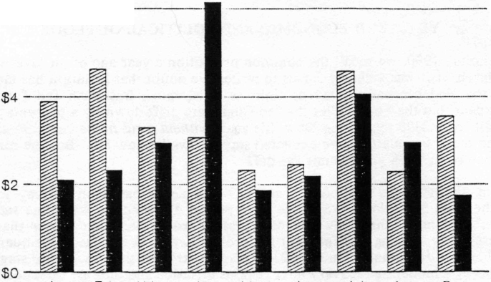
1989
1988
Jan Feb Mar Apr May Jun Jul Aug Sep
Dun & Bradstreet
After-Tax Corporate Profits
with Inventory Valuation Adjustment and Capital Consumption Adjustment

billions

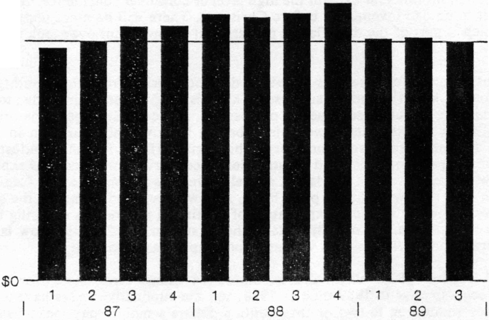
$170

